**Project Plan, Team Charter**

**<Name of Project>**

**<Partner Organization>**

|  |  |
| --- | --- |
| Industry Partner |  |
| Primary Instructor |  |
| Team Member |  |
| Team Member |  |
| Team Member |  |
| Team Member |  |
| Team Member |  |

Document Revision History

|  |  |
| --- | --- |
| Revision # | Date |
|  |  |

**Table of Contents**

**1. Executive Summary**

The following describes the project to be executed.

|  |  |
| --- | --- |
| Objective |  |
| Corporate Goals Addressed |  |
| Planned Start Date |  |
| Planned End Date |  |

**2. Project Approvers, Reviews and Distribution List**

Approvers, reviewers and distribution list

|  |  |  |  |
| --- | --- | --- | --- |
| Project Role | Name | E-mail | Date |
|  |  |  |  |
|  |  |  |  |
|  |  |  |  |
|  |  |  |  |
|  |  |  |  |
|  |  |  |  |

**3. Scope**

Define the sum total of all of its products and their requirements or features.

|  |  |
| --- | --- |
| In Scope | Out of Scope |
|  |  |
|  |  |
|  |  |
|  |  |

**4. Deliverables**

This project will deliver the following.

|  |  |
| --- | --- |
| Deliverable | Description |
|  |  |
|  |  |
|  |  |
|  |  |
|  |  |

**5. Assumptions**

This project makes the following assumptions;

**6. Dependencies**

The following are the internal and external dependencies that will have to be acknowledged and addressed;

**7. Risk Management**

|  |  |  |  |
| --- | --- | --- | --- |
| Potential Risk | Severity (H/M/L) | Likelihood (H/M/L) | Management Strategy |
|  |  |  |  |
|  |  |  |  |

**8. Communication**

**Reporting**

The following reports will be produced;

|  |  |  |
| --- | --- | --- |
| Report | Audience | Frequency |
|  |  |  |
|  |  |  |

**Meetings**

The following meetings/communication will be established;

|  |  |  |  |
| --- | --- | --- | --- |
| Meeting | Purpose | Attendees | Frequency |
|  |  |  |  |
|  |  |  |  |

**9. Task Listing (WBS- Work Breakdown Structure)**

The following resource proposal template summarizes the resource hours committed to this project, upon final approval of this document.

|  |  |  |  |
| --- | --- | --- | --- |
| Reference | Tasks | Duration | Dependency |
| A |  |  |  |
| B |  |  |  |
| C |  |  |  |
| D |  |  |  |
| E |  |  |  |

**10. Gantt Chart**

Create a Gantt Chart from your Task Listing

|  |  |  |  |  |  |  |  |  |  |  |  |
| --- | --- | --- | --- | --- | --- | --- | --- | --- | --- | --- | --- |
| Task | Weeks | | | | | | | | | | Complete |
|  | 1 | 2 | 3 | 4 | 5 | 6 | 7 | 8 | 9 | 10 |  |
|  |  |  |  |  |  |  |  |  |  |  |  |
|  |  |  |  |  |  |  |  |  |  |  |  |
|  |  |  |  |  |  |  |  |  |  |  |  |
|  |  |  |  |  |  |  |  |  |  |  |  |
|  |  |  |  |  |  |  |  |  |  |  |  |
|  |  |  |  |  |  |  |  |  |  |  |  |

**11. Milestones**

|  |  |  |
| --- | --- | --- |
| Major Activity or Milestone | Estimated Milestone Target date | Owner/Reviewer Team Members |
|  |  |  |
|  |  |  |
|  |  |  |
|  |  |  |
|  |  |  |

**12. RAM – Responsibility Assignment Matrix**

Create a RAM from your Task Listing. A sample is shown below:

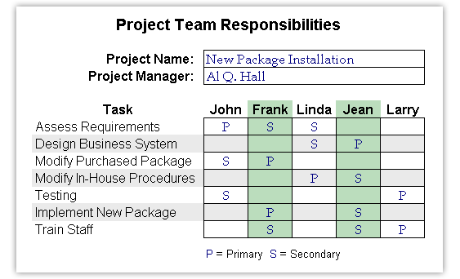

**13. Approval**

The signatures below indicate their approval of the contents of this document.

|  |  |  |  |
| --- | --- | --- | --- |
| Project Role | Name | Signature | Date |
|  |  |  |  |
|  |  |  |  |
|  |  |  |  |
|  |  |  |  |
|  |  |  |  |
|  |  |  |  |

**TEAM CHARTER**

Multiple reasons exist for preparing a team charter. One is to document the team's purpose and clearly define individual roles, responsibilities, and operating rules. Next, it establishes procedures for both the team and management/industry partner on communicating, reporting, and decision-making procedures. It lays out a blueprint for conducting business for the acquisition and defines how the team works in an empowered manner, including setting out responsibility and authority. Finally it facilitates stakeholder buy in by including key members in the decision making process and obtaining their concurrence along the way.

The charter includes the following sections:

1. Purpose

(Describe the purpose for forming the team and the anticipated outcomes.)

2. Background

(Summarize the program or project the team is supporting, state how the team fits within the organizational structure, identify who are the users/customers of the program/project including external customers and stakeholders, sand describe special circumstances surrounding the project.)

3. Scope

(State the scope, mission, and objectives for the project and the team's role in achieving it. This is similar to preparing a mission need statement. Define the high level goals the team must accomplish.)

4. Team composition

(Identify the functional areas represented, the number of members from each, state who are core [essential] members versus support or advisory members and full or part time designation, and the anticipated time/resources commitments involved over the anticipated duration of the team.)

5. Team empowerment

(Define existing authority the team, by virtue of its individual membership, already possesses, additional authority needed to fully perform as envisioned by the team objectives, and level of empowerment requested.)

6. Team operations

(Describe team operational plans. This includes, for example, such activities as the team's decision-making processes, how changes in membership occur should the need arise, plans to establish "ground" or operating rules, relationships with other organizational entities or teams, logistical support, etc.)

7. Team Performance Assessment

(Document key areas of performance needed for team success along with means of measuring progress.)

8. Signature Page

(Each team member signs, agreeing to the contents and being held mutually accountable for adherence.)

​